H8 development kit brief introduction

H8 is based on Allwinner A80 SoC is released by Merrii, we can provide users with Android4.4.2 / inux3.4.39+qt and Lubuntu to develop board.

A80 Hummingbrid H8 is a mini board based on A80, there are two USB hosts, an 3.0 OTG, a Gigabit Ethernet , a WIFI/BT4.0 as well as line in and HDMI HD video output besidesVGA output, support 3G/4G. It has all the basic functions of a PC when connect TV and keyboard, such as preadsheets, word processing, play games and HD videos etc.

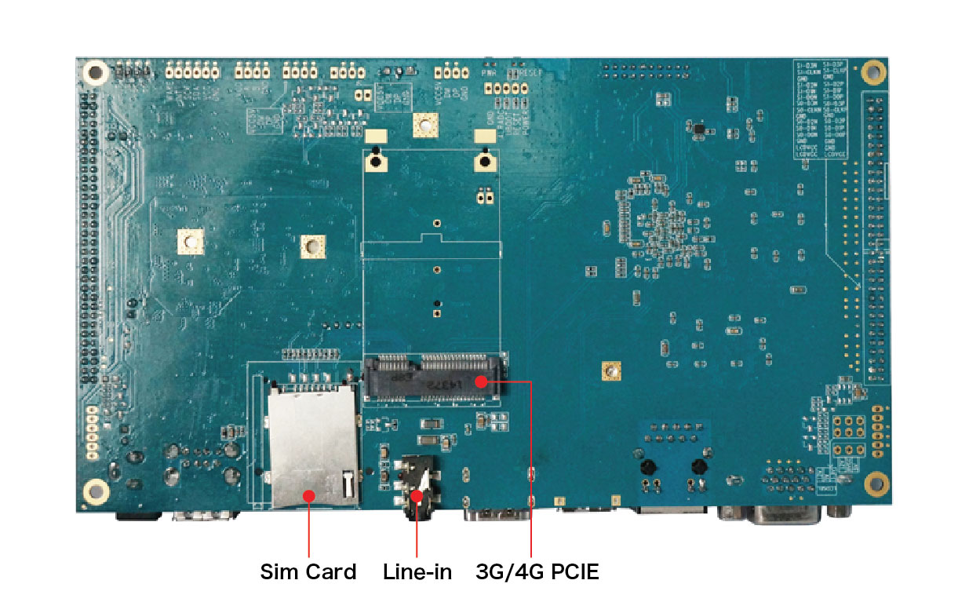
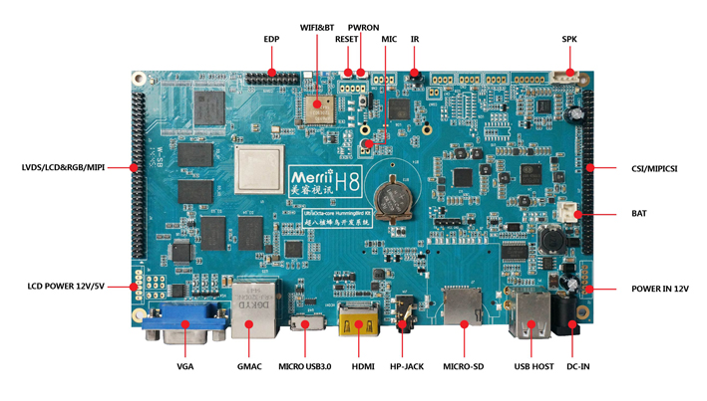

●Specifications Of A80 SoC

A80 Hummingbrid H8 based on Allwinner UltraOcta A80 processor. A80 processor enriched with interfaces, including HDMI，EDP，LVDS/RGB LCD， USB & GMAC.

A80 processor applies the UltraOcta core ARM big.LITTLE Cortex-A15/A7 structure, both efficient of the Cortex-A15 and energy-saving of Cortex-A7. Equipped with POWERVR G6230 GPU, which is not only improves the system performance, but also satisfy the excellent game compatibility.
In addition, A80 supports 4K*2K@30fps decoding，4K*2K@30fps coding and HD 1080p@120fps coding.

CPU | - Octa-core big.LITTLE ARM Cortex-A15/A7
GPU | - PowerVR 64core G6230 GPU
GPU | - Comply with OpenGL ES 3.0/2.0/1.1 OpenCL 1.1 Direct 9.3
Video | - HD H.264 4k*2k@30fps video decoding
Video | - Multi-format FHD video decoding, including Mpeg1/2, Mpeg4 SP/ASP GMC, H.263, H.264 BP/MP/HP, VP8, WMV9/VC-1, Jpeg/Mjpeg, etc.
Video | - 264 High Profile 4096*2048@30fps、1080p@120fps or 720p@240fps encoding
Video | - 3840x1080@30fps 3D encoding/decoding, BD/SBS/TAB/FP supported
Video | - Comply with RTSP, HTTP,HLS,RTMP,MMS streaming media protocols
Display | - Support multi-channel HD display
Display | - Integrated HDMI 1.4 transmitter with HDCP support
Display | - CPU/RGB/LVDS LCD interface
Display | - Support YPbPr/VGA
Camera | - Integrated parallel and MIPI I/F sensor
Camera | - Support 8/10/12-bit YUV/Bayer sensor
Camera | - Support 5M/8M/12M/16M CMOS sensor
Memory | - RAW NAND Flash controller with 72-bit ECC
Memory | - DDR3/DDR3L/LPDDR3/LPDDR2 controller,up to 8G
Audio | - Integrated digital audio interface
OS | - Android 4.4.2 、linux3.4.39

Structure of A80
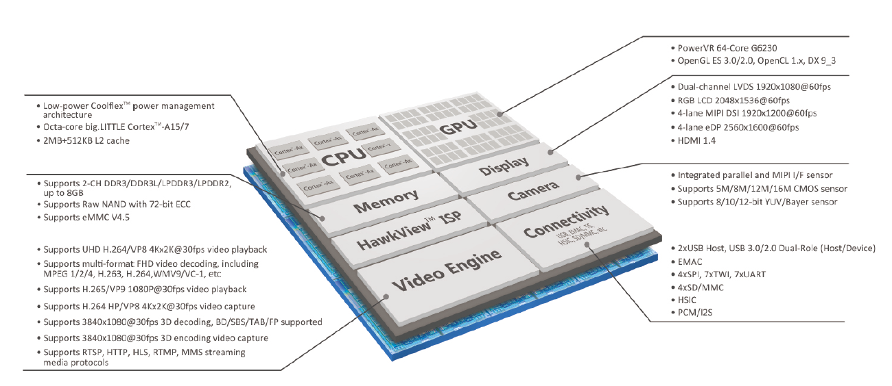

●Highlights Of A80
The main specifications of A80 UltraOcta -core mobile application processor are as following:
-octa-core big.LITTLE Cortex®-A15/A7 CPU structure
-PowerVR G6230 GPU
-H.265/VP9 1080P@30fps video playback
-H.264/VP8 4K*2k@30fps、1080p@120fps or 720p@240fps video encoding.
-3840x1080@30fps 3D codec, support BD/SBS/TAB/FP format
- built-in HDMI, an LVDS, etc
- The highest 16 m CMOS sensor
- Through Google CTS test, GMS in the grant application
- support Android 4.4.2 operating system

Strong ability of high-definition video processing
A80 processor supports 4096*2048@30fps video playback，4096*2048@30fps video coding，1080p@120fps/720p@240fps video coding, provide users a better experience.

High level of integration
High level of integration has been one of the highlights of SoC products, A80 is no exception, the platform integrates an LVDS, HDMI, EDP to make the system design simpler and BOM cost more competitive, products to market more quickly.

●Software features
Driver support: LCD, Touch Screen, UART, Gigabit Ethernet, HDMI, EDP, etc
Support from emmc Flash, SD card startup guide.
Default Android4.4 system, and provide Linux 3.4 source code
Linux OS Features:
    - Linux version: linux 3.4
Android OS Features：
    - Android Version: android 4.4.2 and above

Description Of Hadware Interface
Name | Description
CPU | Cortex-A15/A7 PowerVR G6230
PMU | X-Power AXP806+AXP809 smart power management specialist ,accessible to 12Vpower adapter, battery, USB5V power input
DRAM | 4*16 Bits DDR3 into 64bit 2048M Bytes DRAM
Flash | SDIN7DU2-8G
TF card | Support up to 32G card memory, support card test
WIFI | Wifi BT two-in-one module
Ethernet | 10M/100M/1000M IEEE802.3，use Realtek RTL8211D/E RJ45
USBHost/USBOTG | 1 个 USB OTG 3.0/2.0 ，2USB Host
Headphone | Support stereo headphone output/line in
HDMI output | HDMI v1.4， support 4k at the most
UART | Provide UART interface, TTL level
Keys | RESET，POWER_ON etc
IR | IR only supports infrared remote control
DC | 5V DC IN

●Description of Extended PIN

CSI camera output(J11)
Pin | Pin Name | IO type | Pin | Pin Name | IO type
1 | VCC-5V |  | 2 | CSI0-D2
3 | VCC-3V |  | 4 | CSI0-D3
5 | CSI0-PCLK |  | 6 | MIPI-CSI-SCK
7 | MIPI-CSI-SDA |  | 8 | CSI0-VSYNC
9 | CSI0-HSYNC |  | 10 | CSI0-MCLK
11 | CSI0-D4 |  | 12 | CSI0-D5
13 | CSI0-D6 |  | 14 | CSI0-D7
15 | CSI0-D8 |  | 16 | CSI0-D9
17 | CSI0-D10 |  | 18 | CSI0-D11
19 | GND |  | 20 | GND
21 | CSI0-D0 |  | 22 | CSI0-D1
23 | HUB_PWR_EN |  | 24 | GND
25 | GND |  | 26 | TW2-SCK
27 | UART-RX |  | 28 | TW2-SDA
29 | UART-TX |  | 30 | SPI-CS0
31 | UART-RTS1 |  | 32 | SPI-CLK
33 | UART-CTS1 |  | 34 | SPI-MOSI
35 | GND |  | 36 | SPI-MISO
37 | UART-RX1 |  | 38 | CSI-SCK
39 | UART-TX1 |  | 40 | CSI-SDA
41 | VCC-3V |  | 42 | MIPI-CSI-MCLK

CON18 MIPI camera signal output
Pin | Pin Name | IO type | Pin | Pin Name | IO type
1 | CSI-CLKP |  | 2 | CSI-CLKN
3 | GND |  | 4 | GND
5 | CSI-D2P |  | 6 | CSI-D2N
7 | CSI-D0P |  | 8 | CSI-D0N
9 | CSI-D3P |  | 10 | CSI-D3N
11 | CSI-D1P |  | 12 | CSI-D1N
13 | CSI-MCLK |  | 14 | CSI-SCK
15 | CSI-RESET |  | 16 | CSI-SDA
17 | CSI-PWDN |  | 18 | CSI-ID
19 | VCC-IO-CAM |  | 20 | VDD-CAM
21 | AFVCC-CAM |  | 22 | AVCC-CAM

J4 LVDS signal output
Pin | Pin Name | IO type | Pin | Pin Name | IO type
1 | VCC-LVDS |  | 2 | VCC-LVDS
3 | VCC-LVDS |  | 4 | GND
5 | GND |  | 6 | GND
7 | LVDS0-D0N |  | 8 | LVDS0-D0P
9 | LVDS0-D1N |  | 10 | LVDS0-D1P
11 | LVDS0-D2N |  | 12 | LVDS0-D2P
13 | GND |  | 14 | GND
15 | LVDS0-CLKN |  | 16 | LVDS0-CLKP
17 | LVDS0-D3N |  | 18 | LVDS0-D3P
19 | LVDS1-D0N |  | 20 | LVDS1-D0P
21 | LVDS1-D1N |  | 22 | LVDS1-D1P
23 | LVDS1-D2N |  | 24 | LVDS1-D2P
25 | GND |  | 26 | GND
27 | LVDS1-CLKN |  | 28 | LVDS0-CLKN
29 | LVDS1-D3N |  | 30 | LVDS1-D3P

CON11 KEY external interface socket
Pin | Pin Name | IO type | Pin | Pin Name | IO type
1 | GND |  | 2 | LRADC0
3 | UBOOT |  | 4 | RESET
5 | POWON

J6 Backlight inverter control interface
Pin | Pin Name | IO type | Pin | Pin Name | IO type
1 | BL_IN |  | 2 | BL_IN
3 | ON/OFF |  | 4 | ADJ
5 | GND |  | 6 | GND

J10 CTP Touch interface
Pin | Pin Name | IO type | Pin | Pin Name | IO type
1 | GND |  | 2 | VCC_3V
3 | I2C_SDA |  | 4 | I2C_SCK
5 | TP_INT |  | 6 | TP_WAKEUP

UART0-DEBUG interface
Pin | Pin Name | IO type | Pin | Pin Name | IO type
1 | GND |  | 2 | VCC
3 | UART0-RX |  | 4 | UART0-TX

UART4
Pin | Pin Name | IO type | Pin | Pin Name | IO type
1 | VCC-3.3V |  | 2 | UART4-TX
3 | UART4-RX |  | 4 | GND

Prospect and Purpose
Due to the expansion interfaces of optimus development system are much
more than some other similar products, and it has got global high attention. Thus
making it very powerful, rich social environment and market value. The more people
participate, the more rapid development, the greater the potential market, followed
by the more purposes. Currently, besides the children's education above-mentioned,
it also can be used as basic computer, home theater HD player etc.
●Following uses:
• multimedia player
• PlayStation
• IPTV
• Emulation box
• Auto PC
• Car GPS
• smart robot
• Server
• Electronic Album
• remote surveillance
• Home alarm apparatus / automation system
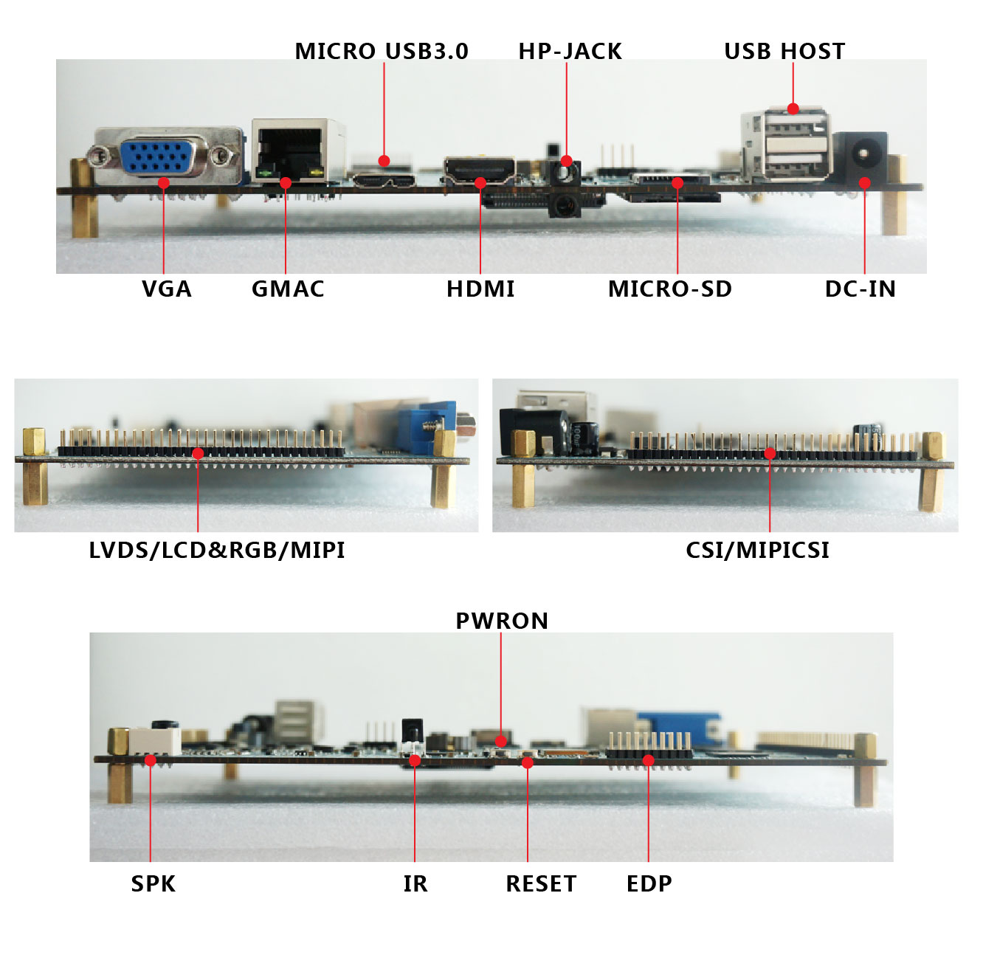

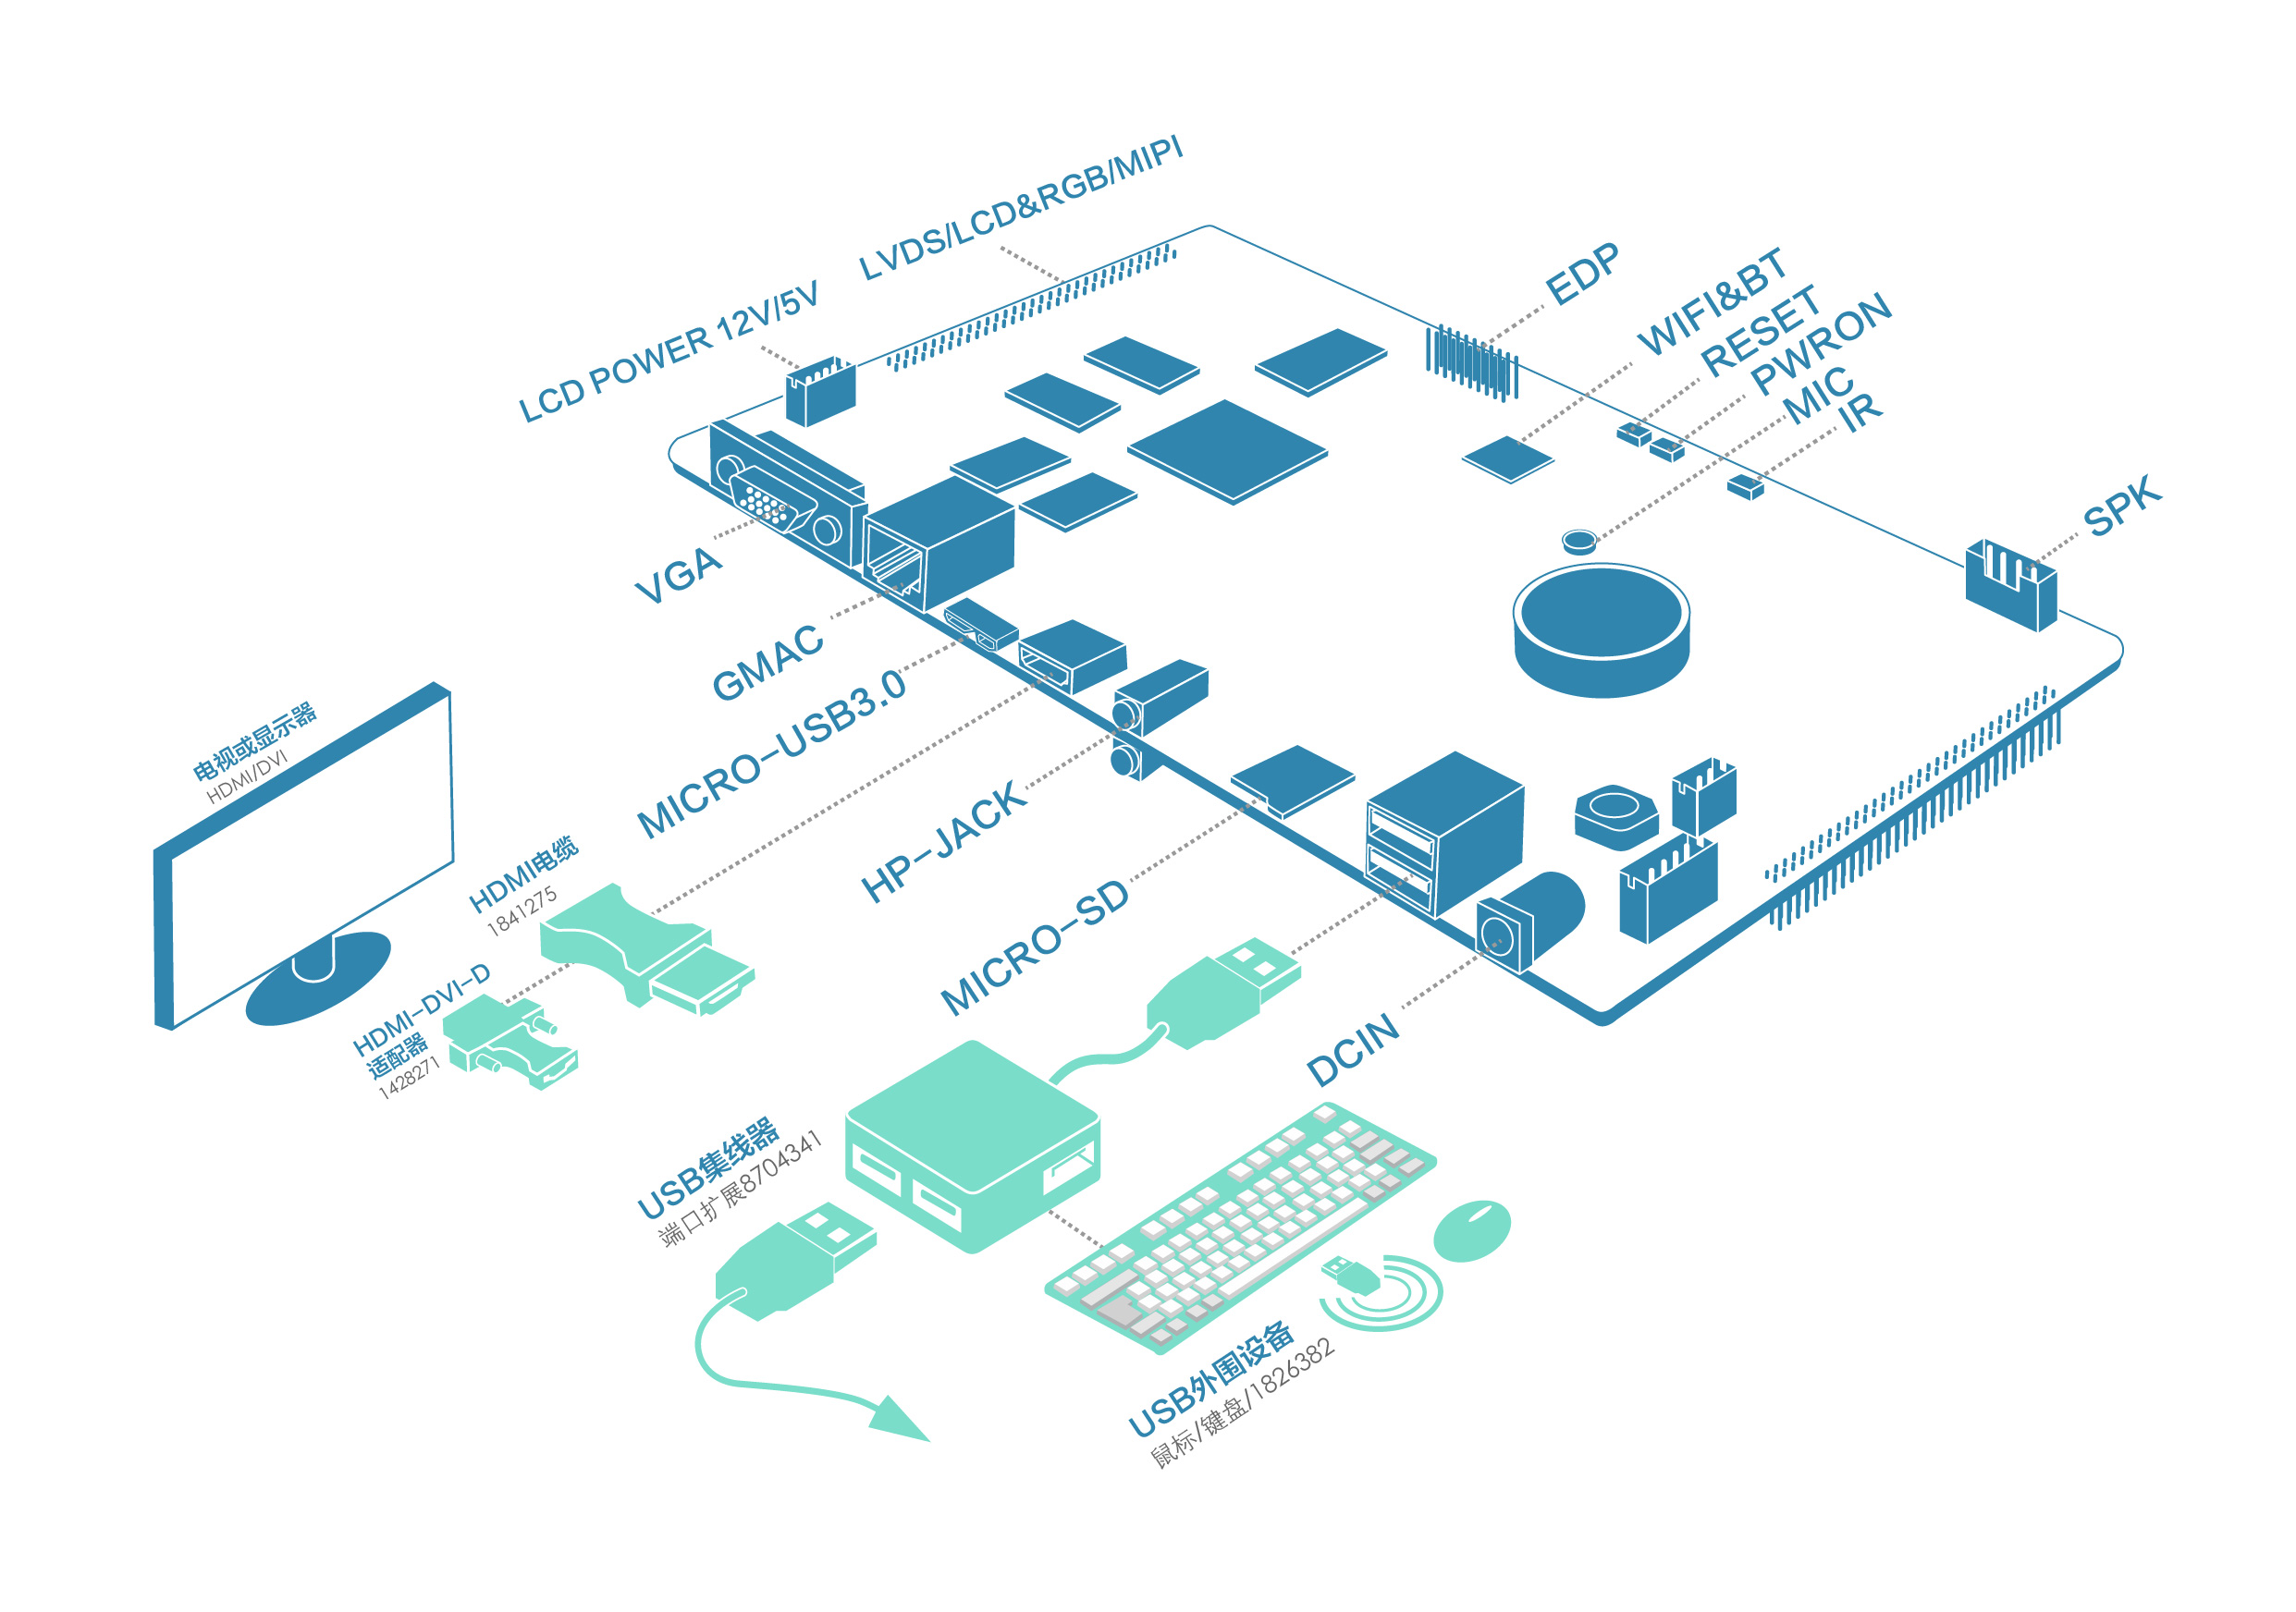

Purchase
Contact person: Danielle
Tel：+86-755-86196321-808
Fax：+86-755-86196240
mobile：13322998873
Q Q：2373876277
Email: hd @merrii.com

